# Input data in the EUROfusion TIMES Model (ETM)

## Main characteristics of ETM

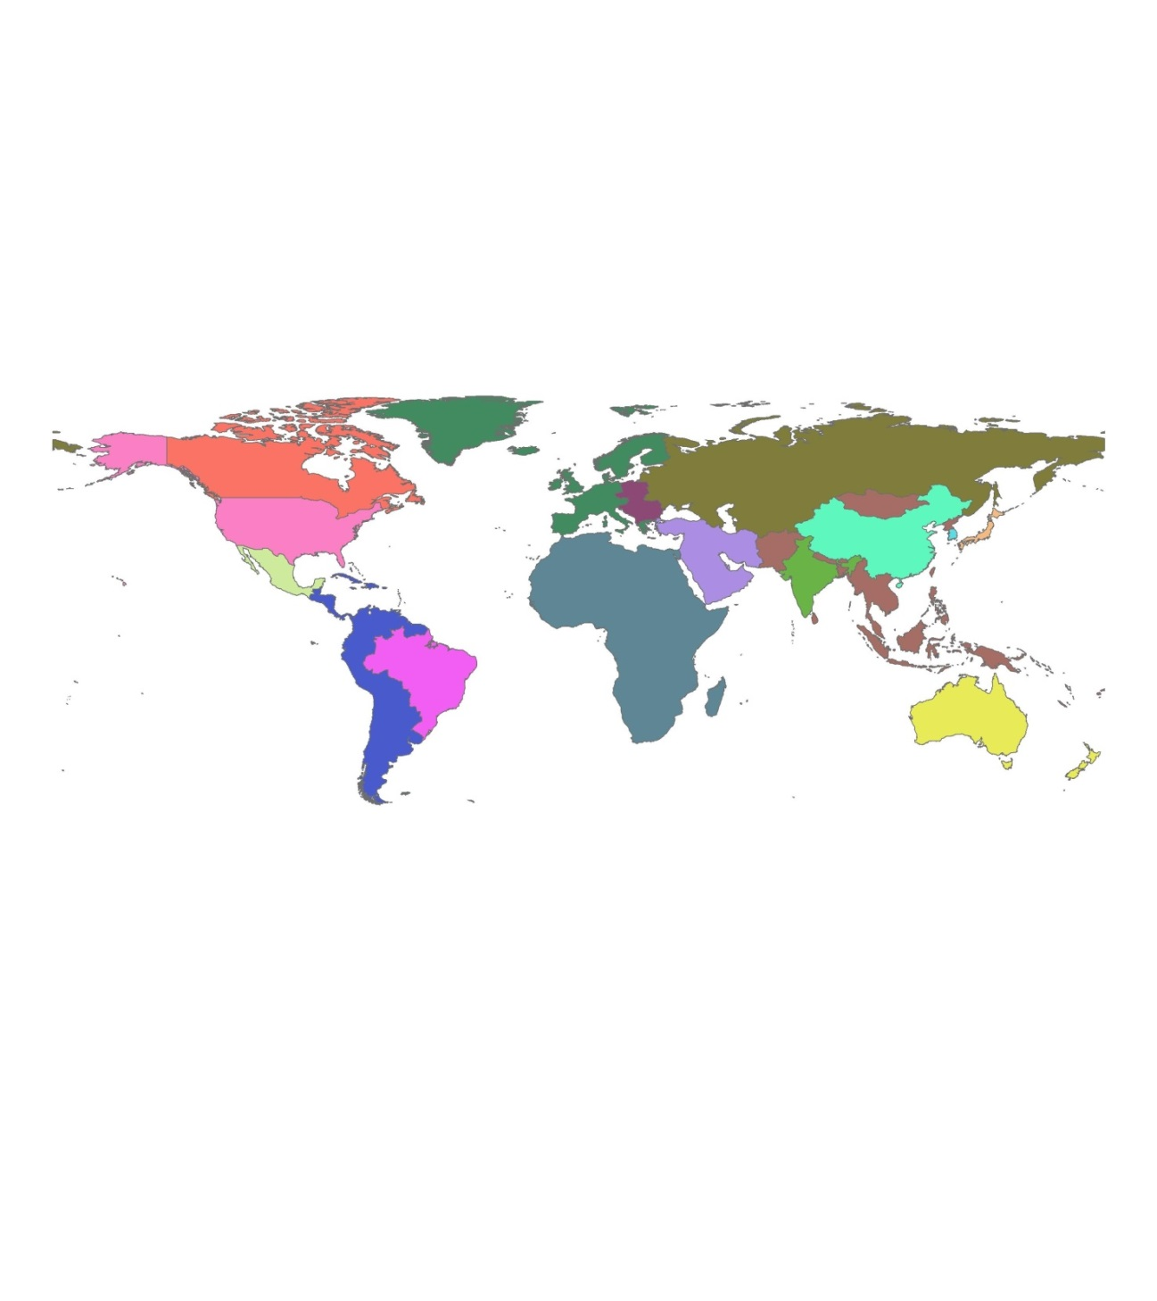

* 17 world regions: Africa, Australia-New Zealand, Brazil, Central Asia and Caucasus, Canada, China, Europe, India, Japan, Middle East, Mexico, Other Developing Asia, Other Eastern Europe, Other Latin America, Russia, South Korea, and United States
* Time horizon: 2100
* Six time slices: three seasons (winter, summer and intermediate), and day/night
* Demand sectors: residential, commercial, agriculture, industry, and transportation
* Supply sectors: electricity and heat production, and upstream/downstream
* Demand scenarios: energy demand driver projections from the general equilibrium models GEM- E3 and Gtap
* Trade: inter-regional exchange process (trade of commodities) among the different regions

## Existing technologies

The model database contains data on each technology generating electricity or heat in the residential, commercial, transport, industry, power and heat generation and upstream (refining, mining, harvesting,…) sectors. Each technology is characterized by the availability factor (AF), efficiency (EFF) and residual capacity installed (RESID). Those existing technologies have a lifetime and as they reach the end of their life, they are substituted by new technologies. So the residual capacity installed is the capacity of those technologies which decreases from one period to the following.

Table 1. Example of existing power plants

|  |  |  |  |  |
| --- | --- | --- | --- | --- |
| **Fuel** | **AF (%)** | **EFF (%)** | **RESID 2005 (GW)** | **RESID 2100 (GW)** |
| Oil | 90 | 35 | 45.94 | 0 |
| Gas | 90 | 48 | 100 | 0 |
| Coal | 90 | 36 | 138.61 | 0 |
| Biomass | 90 | 27 | 2.32 | 0 |
| Hydro | 95 | 99 | 165.37 | 0.75 |
| Nuclear | 96 | 31 | 135.18 | 0 |
| Geo | 95 | 10 | 0.9 | 0.54 |
| Wind | 45 | 99 | 40.74 | 0 |
| Solar | 60 | 99 | 1.77 | 0 |

## New technologies

In the same way, new technologies are well characterized by technical, economic and environmental data in the database. In this case, there are data, among other, on lifetime (LIFE), investment costs (INVCOST) for different periods, fix operation and maintenance costs (FIXOM), variable operation and maintenance costs (VAROM), and AF by season depending on the technology.

Table 2. Example of some new power plants

|  |  |  |  |  |  |
| --- | --- | --- | --- | --- | --- |
| **Technology** | **LIFE (yr)** | **INVCOST 2010 (€/kW)** | **FIXOM 2010 (€/kW)** | **VAROM 2010 (€/MJ)** | **AF (%)** |
| PC | 40 | 1800 | 44.4 | 0.3 | 85 |
| IGCC | 30 | 2000 | 58 | 0.3 | 85 |
| IGCC CCS | 30 | 2667 | 65 | - | 85 |
| PFBC | 30 | 2357 | 58 | 0.3 | 85 |
| Gas/oil ST | 30 | 513 | 22.4 | 0.35 | 85 |
| Gas/oil CC | 30 | 878 | 16.8 | 0.2 | 90 |
| NGCC | 30 | 846.15 | 20 | 0.65 | 90 |
| NGCC CCS* | 30 | 1300 | 27 | - | 90 |
| LWR nuclear | 40 | 1700 | 60 | 0.06 | 90 |
| LWR Advanced | 50 | 5000 | 45 | 0.1 | 85 |
| PBMR nuclear** | 40 | 2300 | 50 | 0.06 | 95 |
| ADS nuclear** | 50 | 5775 | 112 | - | 85 |
| Bio gasification | 25 | 3022.97 | 50 | 4.1 | 90 |
| Bio combustion | 30 | 2055.62 | 80 | 0.7 | 90 |
| Hydro | 70 | 1500-2000 | 10 | 0 | 50 |
| Hydro RoR | 45 | 2500 | 30 | 1.11 | 50 |
| Geo flash | 30 | 1900 | 180 | 0 | 90 |
| Geo Binary | 30 | 2600 | 180 | 0 | 90 |
| Wind onshore*** | 20 | 1179 | 40 | 0 | 19-38 |
| Wind offshore*** | 20 | 2439.3 | 80 | 0 | 34-41 |
| Solar PV*** | 25 | 3065 | 30.65 | 0 | 0-27 |
| CSP-PT*** | 40 | 6151 | 113 | 0 | 8-100 |
| CSP-ST*** | 40 | 11023 | 204 | 0 | 67-100 |
| Wave | 20 | 3340 | 120 | 0 | 35 |
| Tide | 20 | 2400 | 60 | 0 | 35 |
| **Fusion power plants technologies** | | | | | |
| Basic**** | 40 | 5910 | 65.8 | 2.16 | 85 |
| Advanced***** | 40 | 4220 | 65.3 | 2.14 | 85 |

* In 2020

** In 2030-2040

*** AF depends on season

**** In 2050

***** In 2070

PC= Pulverized Coal

IGCC= Integrated Gasification Combined Cycle

CCS= Carbon Capture and Storage

PFBC= Pressurized Fluidized Bed Combustion

ST= Steam Turbine

CC= Combined Cycle

NGCC= Natural Gas Combined Cycle

LWR= Low Water Reactor

PBMR= Pebble Bed Modular Reactor

ADS= Accelerator Driven Systems

RoR= Run of river

PV= Photovoltaic

CSP= Concentrated Solar Power

PT= Parabolic Troughs

ST= Solar Tower

## Socio-economic drivers

Socio-economic drivers are considered which describe the assumed development of certain key indicators, which trigger the energy demand and therefore have a major influence in achieved scenarios.

Table 3. List of considered socio-economic drivers

|  |  |
| --- | --- |
| **Driver** | **Description** |
| GDP | GDP |
| GDPP | GDP per capita |
| GDPPHOU | GDP per household |
| HOU | Number of household |
| PAGR | Value Added Agricolture |
| PCHEM | Value Added Chemical sector |
| PISNF | Value Added Iron and Steel and Non Ferrous metals |
| POEI | Value Added Other Energy Intensive industries |
| POI | Value Added Other Industries |
| POP | Population |
| PSER | Value Added Service sector |

## Trade

* Imports of coal between two regions
* Imports of Uranium
* Delivery cost of electricity, natural gas, crude oil, and coal between two regions

## Trade costs

Import and export costs of coal, crude oil, diesel, biodiesel, gasoline, heavy fuel oil, naphtha, natural gas, and uranium

## Power plants growth

Constraints in each kind of power plants growth

## Potentials

Renewable resources potentials per region for hydro, wind, biomass, solar thermal, geo and ocean

## Fossil and nuclear fuels resources

Data on conventional (oil, coal, gas) and unconventional (shale oil, shale gas, oil sands) fossil fuels, and nuclear (Uranium and Lithium for fusion) fuels resources per region regarding extraction costs and reserves.

**CO2 emissions targets**

Three different CO2 scenarios can be modelled corresponding to the three Representative Concentration Pathways (RCPs): RCP6, RCP4.5 and RCP2.6

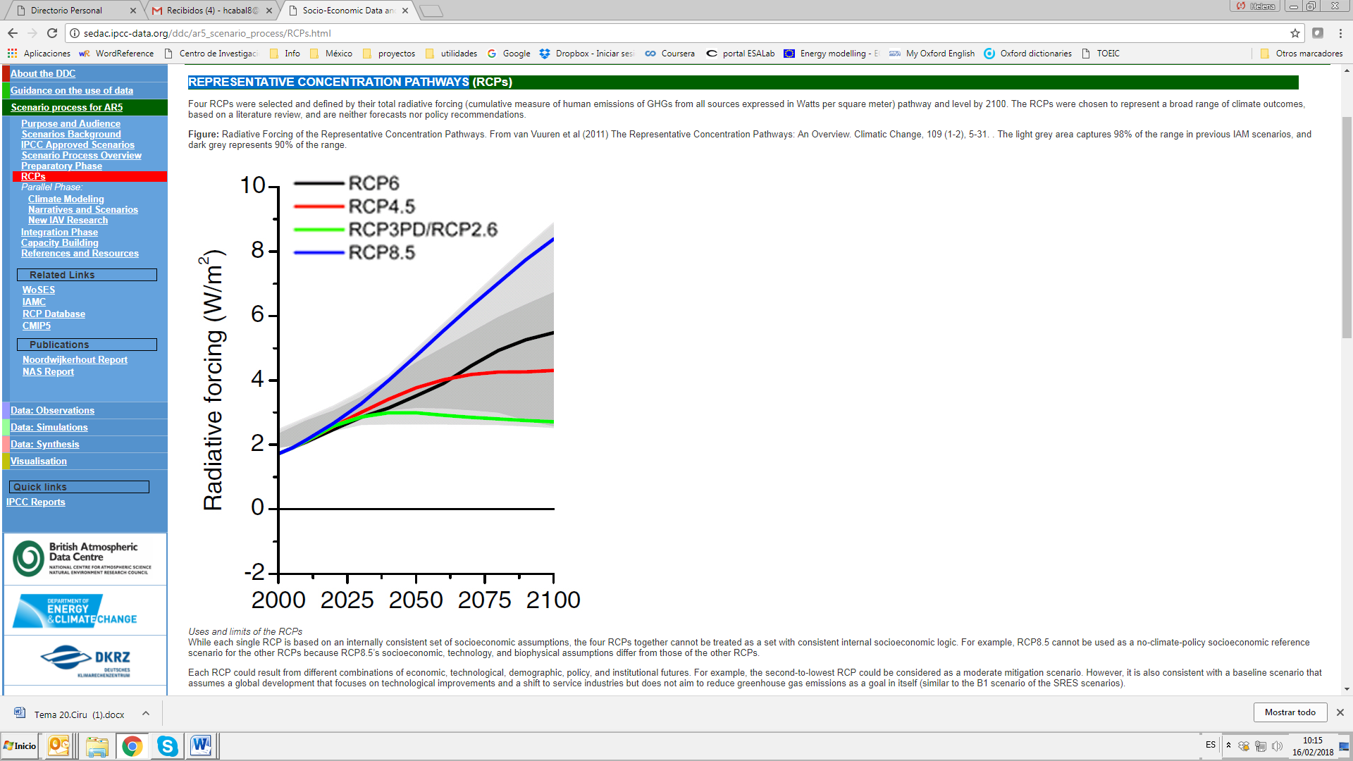

Figure: Radiative Forcing of the Representative Concentration Pathways. From van Vuuren et al (2011) The Representative Concentration Pathways: An Overview. Climatic Change, 109 (1-2), 5-31. The light grey area captures 98% of the range in previous IAM scenarios, and dark grey represents 90% of the range.

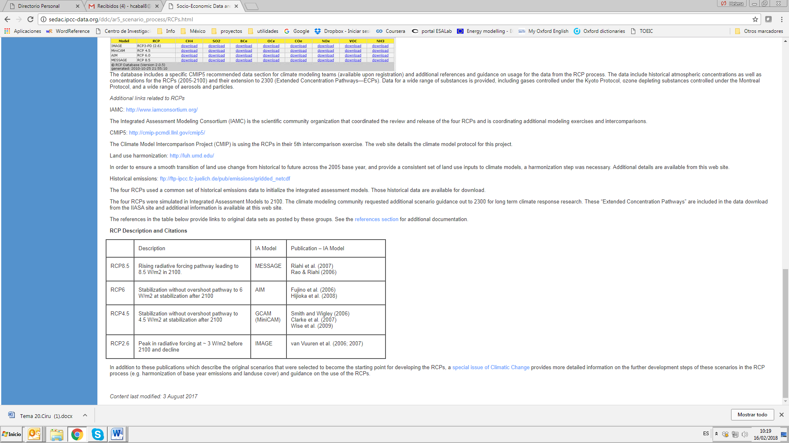

The model can build different environmental scenarios from the less strict one to the strictest choosing among these three CO2 emissions targets.

**Fuel prices**

Gas, oil and biomass prices per region

**Lead time**

Total time required to build a power plant

**Technology specific discount rate**

Discount rate is a multiplier that converts anticipated returns from an investment project to their present value. It is specific of each technology. A high discount rate means that investors have short-term views when deciding their investments. On the contrary, a low discount rate means that investors have long-term views when deciding their investments. ETM can analysed the effect of the discount rate for a specific technology.

**Demand elasticity**

In ETM, the future energy demand is endogenously calculated from the projection of the exogenous socio-economic drivers. In addition, the demand is elastic, that means that, f.e., electricity demand varies with its price. In ETM, demand elasticity can vary and effects on the energy system can be analysed.